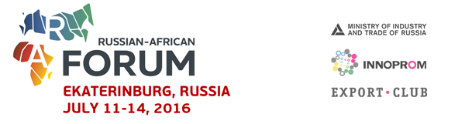

List of African Companies at RAF 2016
 | Company | Country
 | GROUPE BREBA FINANCE | Burkina Faso
 | AFRICOM GROUP | Burkina Faso
 | Cabinet AKILO | Burkina Faso
 | ACM | Burkina Faso
 | PPS SARL | Burkina Faso
 | ALTERNATIVE SARL | BURKINA FASO
 | BETACE SARL | BURKINA FASO
 | KARIBIO/ASY | Burkina Faso
 | SINTRAC SA | BURKINA FASO
 | Chamber of Commerce and Industry of Burkina Faso | BURKINA FASO
 | ECM | BURKINA FASO
 | AFI-MED | BURKINA FASO
 | SYNOVIE | BURKINA FASO
 | DYNAMO West AFRICA | BURKINA FASO
 | IDENTITY BUSINESS SARL | Burkina Faso
 | NAFI OIL | BURKINA FASO
 | Seven’s A | BURKINA FASO
 | AGENCE PASSIF | Burkina Faso
 | SNOW LION | Burkina Faso
 | ETS MOUANSIE FILS | Burkina Faso
 | PROMODIS Sarl | Burkina-Faso
 | Club med | Burkina-Faso
 | Afrimex sarl | Burkina Faso
 | GEPDAF SARL | Burkina-Faso
 | ICO sarl | Burkina-Faso
 | CBT RAKIETA | Burkina-Faso
 | EZOF S.A | Burkina-Faso
 | AFRIQ ECO | Burkina-Faso
 | LORYNE SA | Burkina-Faso
 | MINISTRY OF TRADE | Burundi
 | MINISTERE DES MINES ET DE LA GEOLOGIE | CHAD
 | WEND PANGA | Burkina-Faso
 | MINISTERE DES MINES ET DE LA GEOLOGIE | CHAD
 | SOLID Capital | Egypt
 | TUNASCO | Kenya
 | CONVERGENCE CONSULTING SERVICES | SENEGAL
 | Aeroconsort Group Holdings | South Africa
 | Turnall Holdings | Zimbabwe
 | GeoResearch Group SARL | Камерун
 | Русский Деловой Центр | Камерун
 | Sosumo | Burundi
 | KenInvest | Kenya
 | KenGen | Kenya

